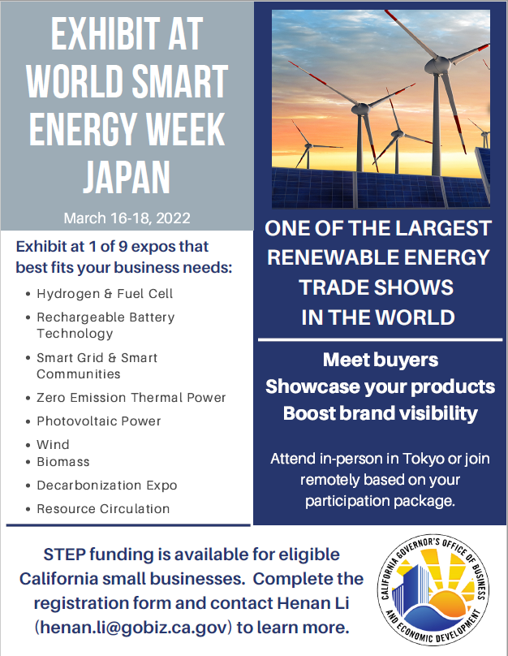
STEP SPONSORED TRADE MISSION APPLICATION FORM
2022 Japan Smart Energy Week
Tokyo Big Sight, Japan| March 16 (Wed.)-18 (Fri.), 2022
Registration Deadline: Nov. 30th, 2021
This application form must be completed in its entirety to be considered eligible. Applications will be reviewed and vetted.
1. Company and Contact Information
Company Name: |  |  |  |  | Submission Date:
Address (Include Street, City, State, Zip Code):
Contact Name: |  |  | Title:
Phone: |  |  | Mobile:
Email: |  |  | Website:
Company Description (Max 150 Words):

What you would like to achieve by participating in the Japan Smart Energy Week Trade Show:
(Please be specific):

2. Participation Options and Cost
There are nine energy sub-sector trade shows that will all be part of the March 2022 Smart Energy Week in Tokyo, Japan. Those sub-sector trade shows will all be occurring simultaneously at the conference center and provide companies the option to select which area is most appropriate for their business. Those sub-sector trade show focus areas are: Fuel Cell Expo, Battery Japan, Decarbonization Expo, Zero Emission Thermal Power Generation Expo, Wind Expo, International Smart Grid Expo, International Photovoltaic Power Generation Expo, Resources Circulation Expo, and International Biomass Expo.

The California STEP Individual Company Export Promotion (ICEP) Program will reimburse eligible California small businesses up to a maximum of $5,000 USD for international export trade show costs. To be eligible for participating the ICEP program, companies must submit this completed form to Ms. Henan Li: henan.li@gobiz.ca.gov by the registration deadline.
In-Person Option
The opportunity to network and engage in-person at the trade show, conduct face-to-face business meetings, directly meet with potential buyers, promote your products directly to customers, and represent your company at the largest energy-related trade show in Japan is an experience second to none. Although current Covid-19 travel restrictions require a quarantine period, we will be providing STEP funding to help eligible small businesses participate in Smart Energy Week in-person. All companies are responsible for monitoring and adhering to any quarantine requirements and all other COVID-19 processes, protocols, and requirements.
In-person Plan:
Cost: Depending on the rental display package you choose the cost for a 8.1 square meter booth is approximate USD $7,063-$7,741 including tax.
Packaged booth Type A : 800,000 JPY +10% tax / 8.1sqm Packaged booth Type B : 730,000 JPY +10% tax / 8.1sqm
Other in-person costs: Participating companies will pay for their own travel (including visa, airfare, hotel, meals, and other associated travel costs (e.g. insurance), shipping (if needed), any additional costs for marketing, hiring personal interpreters etc.
Remote Hybrid Option
This option does not require travel. Companies participating in the hybrid option will have a physical booth that will be staffed by a bilingual booth assistant arranged for onsite at the trade show by the trade show organizer. The booth assistant will:
• Display your products/technologies at business-to-business exhibitions on your behalf
• Explain your products/technologies to your target customers
• Connect with you and your target customers via video calls
• Collect business cards and hand out brochures/samples to your customers (you will cover any shipping costs)
Standard Hybrid Plan  Cost: 730,000 JPY +10% tax / 8.1sqm booth  (approx. USD $7,063)  One bilingual booth assistant for one exhibitor; A fully furnished booth with Rental Display Type B. A PC with internet connection for video calls will be included. | Economy Hybrid Plan  Cost: 520,000 JPY + 10% tax / 8.1sqm booth  (approx. USD $5,032)  One bilingual booth assistant shared with another company for 16.2sqm booth; Only essential and simple decoration with a PC for video calls.

3. Qualification for STEP/ICEP Program
Qualification Requirements
(For both In-Person and Remote Hybrid Options)
- Provide a signed self-attestation identifying as an eligible small business.
- Be organized or incorporated in the U.S. and operating in the U.S.
- Meet the definition of a small business, according to the U.S. Small Business Administration.
- Exporting goods or services of U.S. Origin or that have at least 51% or more U.S. content.
- Registered to do business in the State of California and in good standing.
- Must be in business for at least one year at the time of the approved STEP activity takes place.
- Have sufficient resources to bear the costs associated with trade, including the costs of packing, shipping, freight forwarding, and customs brokers.
- Agree to provide information on export sales data resulting from the STEP reimbursement funding and respond to all subsequent STEP surveys on a timely basis.
Do you qualify for STEP/ICEP program? Yes ( ) No( )

4. Participation Interest
Please identify what type of option your company is interested in:
( ) I am interested in the in-person option
( ) I am interested in the Hybrid option: ( ) Standard Hybrid Plan or ( ) Economy Hybrid Plan

Please indicate the sub-sector trade show where you would be interested to exhibit:
( ) Fuel Cell Expo ( ) Battery Japan ( ) Decarbonization Expo ( ) Wind Expo
( ) Zero Emission Thermal Power Generation Expo ( ) International Smart Grid Expo
( ) International Photovoltaic Power Generation Expo ( )Resources Circulation Expo
( )International Biomass Expo

Space and funding resources are limited. Completing this application does not guarantee acceptance to this STEP-sponsored trade mission. We will be in touch shortly regarding your participation and to outline next steps. For further questions, please contact Ms. Henan Li: henan.li@gobiz.ca.gov Thank you for your interest.

